**Create IBM Watson IoT Platform And Device**

|  |  |
| --- | --- |
| Team ID | PNT2022TMID48082 |
| Project Name | Project – Smart Waste Management System For Metropolitan Cities |

IBM Watson IoT Platform is a complete end-to-end solution for IoT needs. It integrates a bundled set of services to connect, capture, register, analyze, and archive your IoT devices and data.

**This is part two of a two-part series.** This document is a simple, easy to follow process to connect a device to IBM Watson IoT Platform. It will go through connecting via an MQTT connection.

**STEP1:**

Login to IBM Watson IoT Platform to Verify Connection

Go to URL - <https://internetofthings.ibmcloud.com/>

Click Sign in

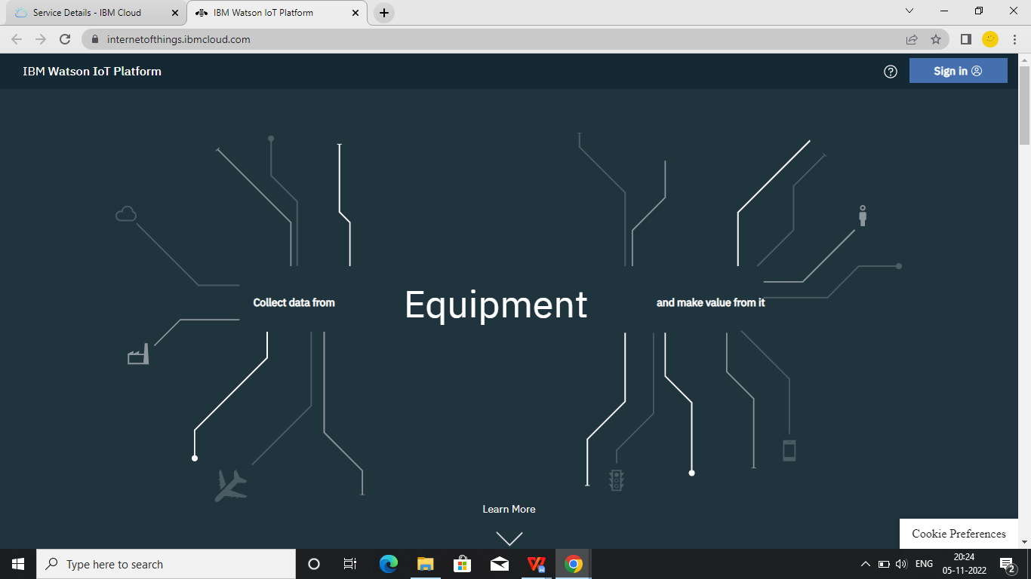

**STEP2:**

Enter an IBMid and click Continue (Click Remember Me if you want)

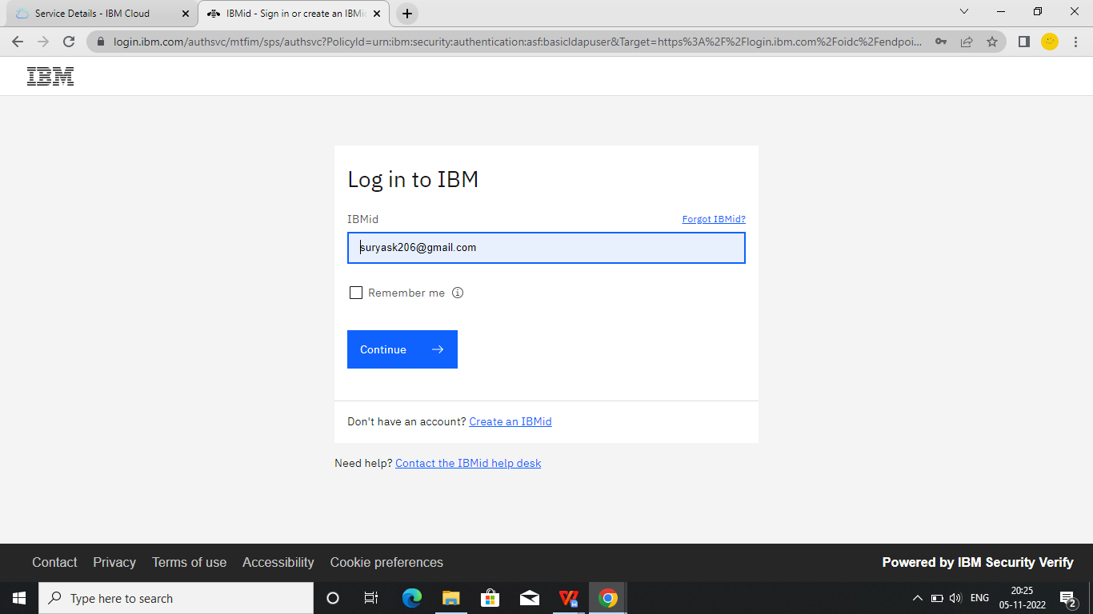

Enter the Password and click Login (Click Remember Me if you want)

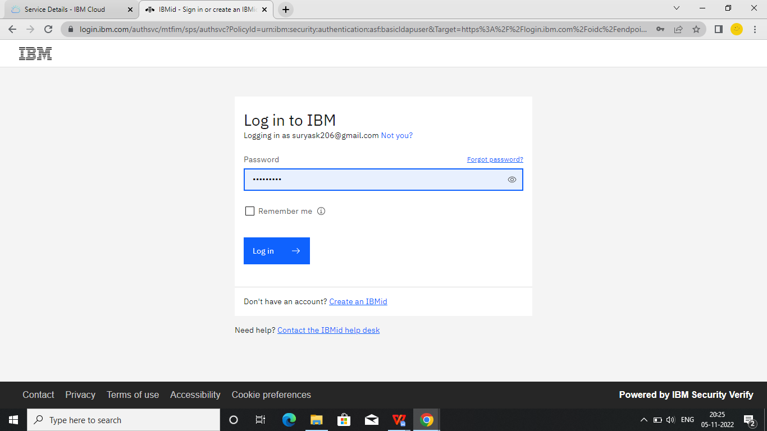

You are now logged into IBM Watson IoT Platform

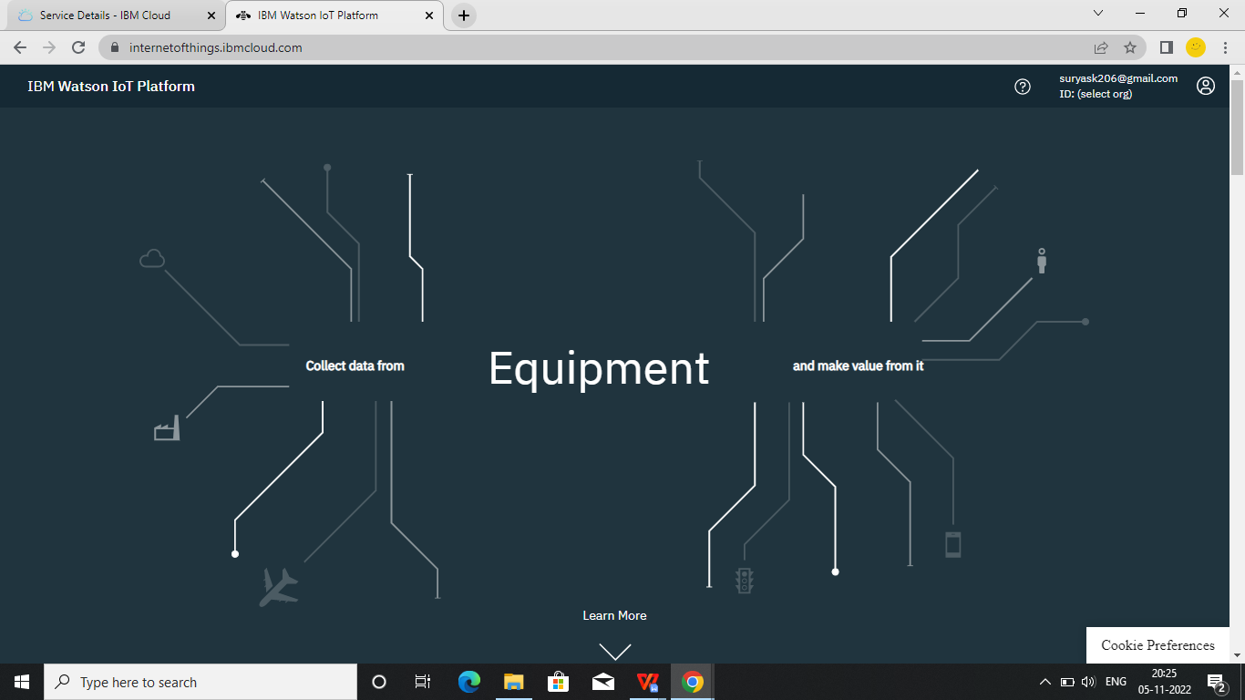

**STEP3:**

Click select org & click the Created ID

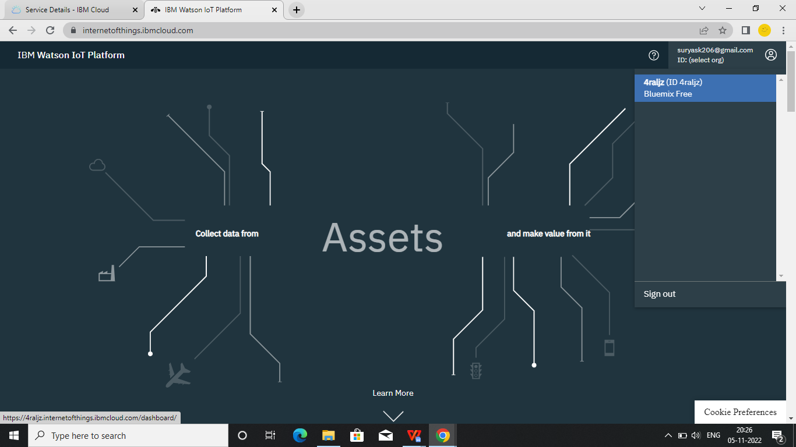

**STEP4:**

Click Devices option and see that the device state.

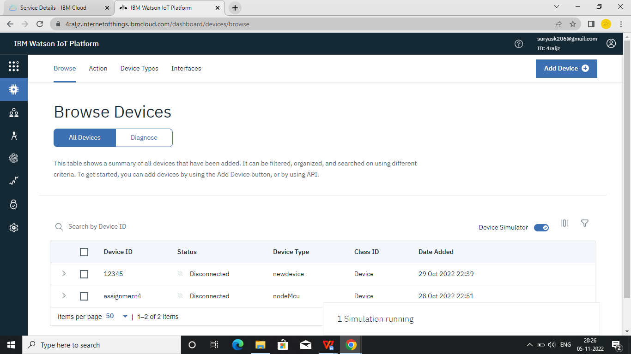

**STEP 5:**

Click the device and Logs and see that the connection was made

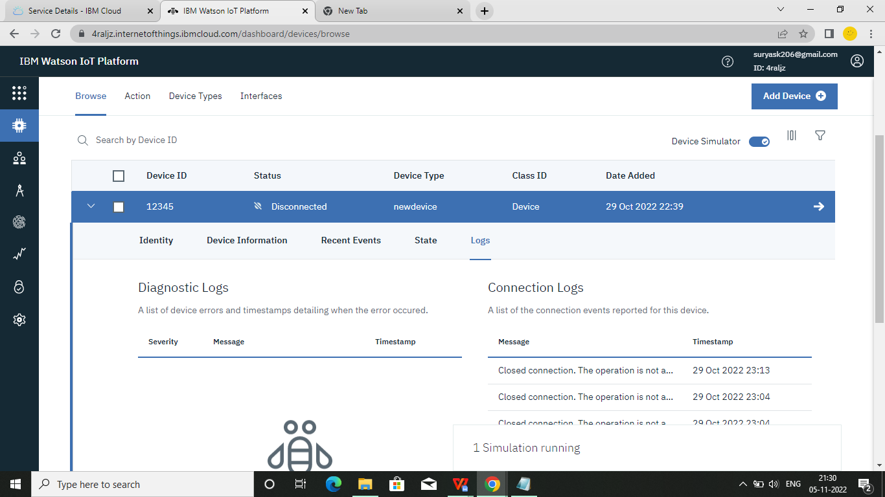

**STEP6:**

Click Recent Events and see the data that was sent from the device to IBM Watson IoT Platform .

